Internet Programming Lab
Experiments 31–40

Experiment 31: Ko-Matha Dairy Farm — Smart Dairy E-Commerce
Design a dairy farm website selling milk, curd, ghee and butter with product descriptions and pricing, plus admin-side stock entry and daily/monthly/yearly reports, customer purchase records, and milk vendor/cow details.

Code
<!DOCTYPE html>
<html><head><meta charset="utf-8"><title>Ko-Matha Dairy</title>
<style>
body{font-family:Segoe UI,Arial;margin:0;background:#fffdf6;color:#2c2c2c}
header{background:#4d7c2a;color:#fff;padding:20px 40px}
header h1{margin:0;font-size:24px}header p{margin:4px 0 0;font-size:13px;opacity:.9}
nav{background:#3c611f;display:flex}
nav a{color:#fff;text-decoration:none;font-size:12px;padding:12px 16px}
.prods{display:flex;gap:14px;padding:22px 40px}
.p{flex:1;background:#fff;border:1px solid #eee;border-radius:8px;overflow:hidden}
.p .sw{height:70px}
.milk{background:#f1f1e8}.curd{background:#fdf3e0}.ghee{background:#fbe3b0}.butter{background:#fff4c2}
.p .body{padding:10px}
.p h4{margin:0 0 4px;font-size:13px}
.p span{color:#4d7c2a;font-weight:bold;font-size:13px}
.stock{margin:0 40px 30px;background:#f6f7ee;border-radius:8px;padding:14px 18px;font-size:12px;color:#555}
</style></head>
<body>
<header><h1>🐄 Ko-Matha Dairy Farm</h1><p>Pure A1 Cow Milk &amp; Dairy Products</p></header>
<nav><a href="#">Home</a><a href="#">Products</a><a href="#">Farm</a><a href="#">Order Online</a><a href="#">About Us</a><a href="#">Contact</a></nav>
<div class="prods">
<div class="p"><div class="sw milk"></div><div class="body"><h4>Fresh A1 Milk (1L)</h4><span>₹80</span></div></div>
<div class="p"><div class="sw curd"></div><div class="body"><h4>Curd (500g)</h4><span>₹45</span></div></div>
<div class="p"><div class="sw ghee"></div><div class="body"><h4>Cow Ghee (250ml)</h4><span>₹320</span></div></div>
<div class="p"><div class="sw butter"></div><div class="body"><h4>White Butter (200g)</h4><span>₹150</span></div></div>
</div>
<div class="stock"><b>Admin — Stock Overview:</b> Milk 120L · Curd 60kg · Ghee 15L · Butter 25kg &nbsp;|&nbsp; Monthly report generated on 1st of every month</div>
</body></html>

Output
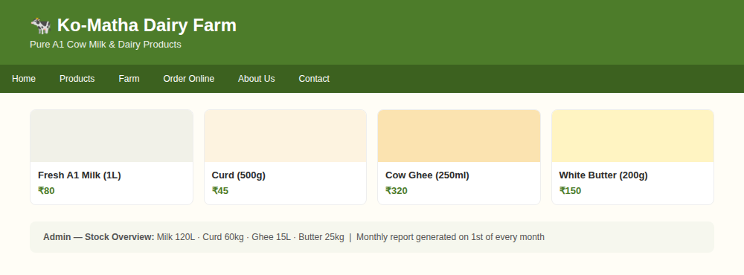

Experiment 32: Ram Infotech — Laptop Sales & Service
Design a website combining an online laptop store with specifications, reviews and pricing, and a service-center module for scheduling repairs, tracking status and troubleshooting guides, alongside admin stock and customer records.

Code
<!DOCTYPE html>
<html><head><meta charset="utf-8"><title>Ram Infotech</title>
<style>
body{font-family:Segoe UI,Arial;margin:0;background:#f5f6fa;color:#222}
header{background:#1a2b4c;color:#fff;padding:18px 40px;display:flex;justify-content:space-between;align-items:center}
header h1{margin:0;font-size:22px}
.tabs{display:flex;gap:10px;padding:12px 40px 0}
.tab{padding:8px 16px;border-radius:6px 6px 0 0;font-size:13px;background:#fff;font-weight:600}
.tab.off{background:#e4e7ee;color:#555}
.grid{display:flex;gap:14px;padding:16px 40px}
.card{flex:1;background:#fff;border-radius:8px;padding:14px;box-shadow:0 1px 4px #0002}
.card h4{margin:0 0 6px;font-size:14px}
.card p{margin:0;font-size:12px;color:#666}
.price{color:#1a2b4c;font-weight:bold;margin-top:8px}
.service{margin:0 40px 30px;background:#fff;border-radius:8px;padding:14px 18px;box-shadow:0 1px 4px #0002;font-size:13px}
.badge{background:#e8f0fe;color:#1a2b4c;font-size:11px;padding:3px 8px;border-radius:10px;margin-left:6px}
</style></head>
<body>
<header><h1>💻 Ram Infotech</h1><span style="font-size:12px">Laptop Sales &amp; Service</span></header>
<div class="tabs"><div class="tab">Online Store</div><div class="tab off">Service Center</div><div class="tab off">About Us</div><div class="tab off">FAQ</div></div>
<div class="grid">
<div class="card"><h4>Dell Inspiron 15</h4><p>i5 · 16GB · 512GB SSD</p><div class="price">₹52,990</div></div>
<div class="card"><h4>HP Pavilion 14</h4><p>i7 · 16GB · 1TB SSD</p><div class="price">₹68,490</div></div>
<div class="card"><h4>Lenovo IdeaPad</h4><p>Ryzen 5 · 8GB · 512GB SSD</p><div class="price">₹41,990</div></div>
</div>
<div class="service"><b>Service Center</b><span class="badge">Track Status</span><p style="margin-top:6px;color:#666">Schedule a repair · Screen replacement · Battery service · Troubleshooting guides</p></div>
</body></html>

Output
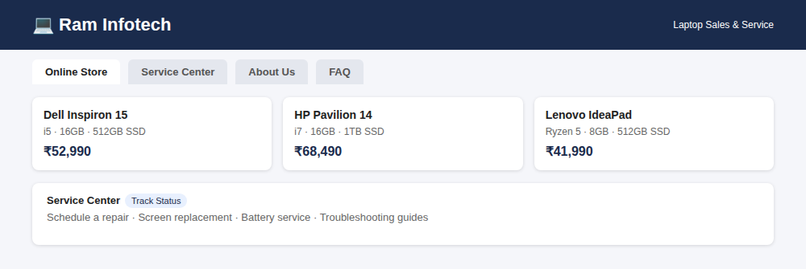

Experiment 33: KodaikanalEats — Restaurant Table Booking
Design a restaurant-booking website for Kodaikanal that lets users search and filter restaurants by cuisine, location and rating, reserve tables with date/time selection, and view restaurant profiles with menus, photos and reviews.

Code
<!DOCTYPE html>
<html><head><meta charset="utf-8"><title>KodaikanalEats</title>
<style>
body{font-family:Segoe UI,Arial;margin:0;background:#fbf7f2;color:#2b2b2b}
header{background:#8c3b2e;color:#fff;padding:20px 40px}
header h1{margin:0;font-size:24px}header p{margin:4px 0 0;font-size:13px;opacity:.9}
.filter{display:flex;gap:10px;padding:16px 40px;background:#fff}
.filter select,.filter input{padding:8px;border:1px solid #ddd;border-radius:4px}
.filter button{background:#8c3b2e;color:#fff;border:0;padding:8px 18px;border-radius:4px}
.list{display:flex;gap:14px;padding:20px 40px}
.r{flex:1;background:#fff;border-radius:8px;overflow:hidden;box-shadow:0 1px 4px #0002}
.r .img{height:80px;background:linear-gradient(135deg,#e0a458,#8c3b2e)}
.r .body{padding:10px}
.r h4{margin:0 0 4px;font-size:14px}
.r span{font-size:12px;color:#777}
.r button{margin-top:8px;background:#f2ede6;border:0;padding:6px 12px;border-radius:4px;font-size:12px}
</style></head>
<body>
<header><h1>🍽 KodaikanalEats</h1><p>Book the best restaurant tables in Kodaikanal</p></header>
<div class="filter"><select><option>Cuisine</option><option>South Indian</option><option>Continental</option></select><input placeholder="Date &amp; Time"><select><option>Rating</option></select><button>Search</button></div>
<div class="list">
<div class="r"><div class="img"></div><div class="body"><h4>Misty Hills Fine Dine</h4><span>★4.7 · Continental</span><br><button>Reserve Table</button></div></div>
<div class="r"><div class="img"></div><div class="body"><h4>Ghat View Café</h4><span>★4.4 · South Indian</span><br><button>Reserve Table</button></div></div>
<div class="r"><div class="img"></div><div class="body"><h4>Pine Grove Bistro</h4><span>★4.6 · Multi-cuisine</span><br><button>Reserve Table</button></div></div>
</div>
</body></html>

Output
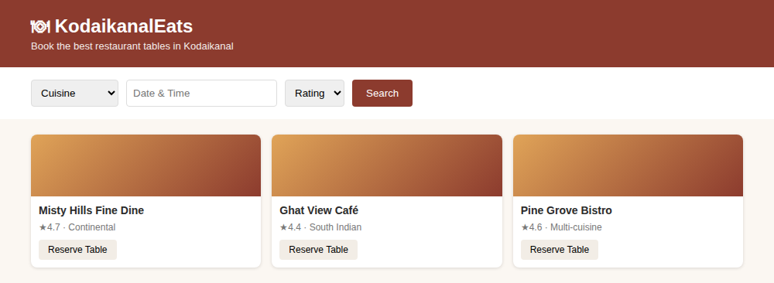

Experiment 34: LearnWell Tuition Centre — Announcements & Registration
Design a tuition-centre website with a central announcements section for class schedules and events, a course-offerings page with subjects/fees, and an online registration system for enrolling students and managing profiles.

Code
<!DOCTYPE html>
<html><head><meta charset="utf-8"><title>LearnWell</title>
<style>
body{font-family:Segoe UI,Arial;margin:0;background:#f3f6fb;color:#222}
header{background:#264653;color:#fff;padding:18px 40px}
header h1{margin:0;font-size:22px}
.ann{margin:16px 40px;background:#fff3cd;border-left:4px solid #e9c46a;padding:10px 16px;font-size:12px;border-radius:4px}
.grid{display:flex;gap:14px;padding:0 40px 20px}
.g{flex:1;background:#fff;border-radius:8px;padding:14px;box-shadow:0 1px 4px #0002}
.g h4{margin:0 0 6px;font-size:14px;color:#264653}
.g p{margin:0;font-size:12px;color:#666}
.reg{margin:0 40px 30px;background:#fff;border-radius:8px;padding:14px 18px;box-shadow:0 1px 4px #0002;display:flex;gap:10px}
.reg select,.reg input{padding:8px;border:1px solid #ddd;border-radius:4px;flex:1}
.reg button{background:#2a9d8f;color:#fff;border:0;padding:8px 20px;border-radius:4px}
</style></head>
<body>
<header><h1>📘 LearnWell Tuition Centre</h1><p style="margin:4px 0 0;font-size:13px;opacity:.9">Course Offerings · Online Registration</p></header>
<div class="ann">📢 Announcement: Semester exam schedule for Grade 10 &amp; 12 released — check Course Offerings page.</div>
<div class="grid">
<div class="g"><h4>Mathematics</h4><p>Grade 9-12 · Mon/Wed/Fri · ₹1500/mo</p></div>
<div class="g"><h4>Physics</h4><p>Grade 11-12 · Tue/Thu · ₹1800/mo</p></div>
<div class="g"><h4>English</h4><p>Grade 9-10 · Sat · ₹1000/mo</p></div>
</div>
<div class="reg"><select><option>Select Subject</option><option>Mathematics</option><option>Physics</option></select><input placeholder="Student Name"><button>Register</button></div>
</body></html>

Output
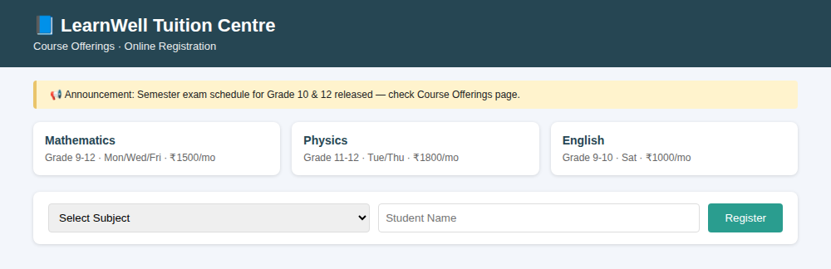

Experiment 35: RouteFare Pass — Student & Route Bus Pass Application
Design a bus-pass application module where a candidate submits name, date of birth, school/organization and validity period, and can track pass approval status, renewal due date and payment amount.

Code
<!DOCTYPE html>
<html><head><meta charset="utf-8"><title>RouteFare Pass</title>
<style>
body{font-family:Segoe UI,Arial;margin:0;background:#eef2f7;color:#222}
header{background:#3d348b;color:#fff;padding:18px 40px}
.form{margin:20px 40px;background:#fff;border-radius:8px;padding:16px 20px;box-shadow:0 1px 4px #0002}
.form h3{margin:0 0 10px;font-size:14px;color:#3d348b}
.row{display:flex;gap:10px;margin-bottom:10px}
.row input,.row select{flex:1;padding:8px;border:1px solid #ddd;border-radius:4px;font-size:12px}
.form button{background:#3d348b;color:#fff;border:0;padding:9px 20px;border-radius:4px;font-size:13px}
.status{margin:0 40px 30px;display:flex;gap:14px}
.s{flex:1;background:#fff;border-radius:8px;padding:12px;box-shadow:0 1px 4px #0002;font-size:12px}
.s b{display:block;font-size:16px;color:#3d348b;margin-top:4px}
</style></head>
<body>
<header><h1 style="margin:0;font-size:22px">🎫 RouteFare Pass</h1><p style="margin:4px 0 0;font-size:13px;opacity:.9">Route &amp; Student Bus Pass Application</p></header>
<div class="form">
<h3>Apply for Route Pass</h3>
<div class="row"><input placeholder="Candidate Name"><input placeholder="Date of Birth" type="date"></div>
<div class="row"><input placeholder="Organization / School Name"><select><option>Validity: Monthly</option><option>Validity: Quarterly</option></select></div>
<button>Submit Application</button>
</div>
<div class="status">
<div class="s">Pass Status<b>Approved</b></div>
<div class="s">Renewal Due<b>05-Sep-2026</b></div>
<div class="s">Amount<b>₹450</b></div>
</div>
</body></html>

Output
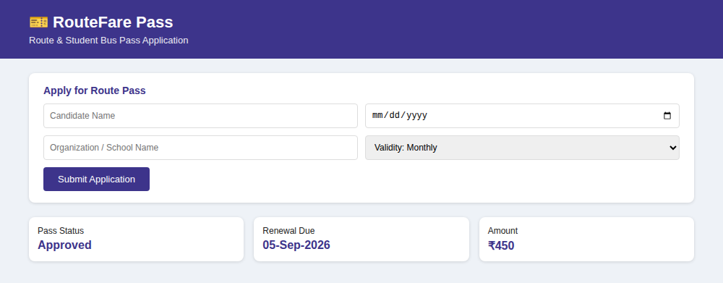

Experiment 36: EduConnect — Online Teaching Platform
Design an online-teaching platform with a course catalog for browsing and enrolling in subjects, live and pre-recorded classes, discussion forums, quizzes and assignments, and an instructor dashboard to track student progress.

Code
<!DOCTYPE html>
<html><head><meta charset="utf-8"><title>EduConnect</title>
<style>
body{font-family:Segoe UI,Arial;margin:0;background:#f7f8fc;color:#222}
header{background:#5e60ce;color:#fff;padding:20px 40px}
header h1{margin:0;font-size:24px}
.tabs{display:flex;gap:16px;padding:12px 40px;background:#fff;font-size:13px;color:#555}
.tabs .on{color:#5e60ce;font-weight:bold;border-bottom:2px solid #5e60ce;padding-bottom:6px}
.courses{display:flex;gap:14px;padding:20px 40px}
.c{flex:1;background:#fff;border-radius:8px;padding:14px;box-shadow:0 1px 4px #0002}
.c h4{margin:0 0 6px;font-size:14px}
.c p{margin:0;font-size:12px;color:#666}
.tag{display:inline-block;background:#eef0fb;color:#5e60ce;font-size:11px;padding:2px 8px;border-radius:10px;margin-top:8px}
</style></head>
<body>
<header><h1>🎓 EduConnect</h1><p style="margin:4px 0 0;font-size:13px;opacity:.9">Online Teaching &amp; Learning Platform</p></header>
<div class="tabs"><span class="on">Course Catalog</span><span>Live Classes</span><span>Assignments</span><span>Discussion Forum</span><span>My Dashboard</span></div>
<div class="courses">
<div class="c"><h4>Data Structures</h4><p>32 lectures · Quizzes &amp; Assignments</p><span class="tag">Live + Recorded</span></div>
<div class="c"><h4>Web Development</h4><p>28 lectures · Project Based</p><span class="tag">Recorded</span></div>
<div class="c"><h4>Digital Marketing</h4><p>18 lectures · Certificate</p><span class="tag">Live</span></div>
</div>
</body></html>

Output
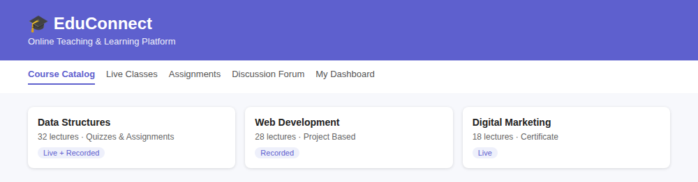

Experiment 37: BookHaven — Online Bookstore
Design a bookstore homepage with curated collections and bestsellers, a search bar, a category page to browse by genre/author, and static pages for About Us, Contact Us and FAQs.

Code
<!DOCTYPE html>
<html><head><meta charset="utf-8"><title>BookHaven</title>
<style>
body{font-family:Georgia,serif;margin:0;background:#fdf9f3;color:#2b2b2b}
header{background:#3a2e2a;color:#fff;padding:18px 40px;display:flex;justify-content:space-between;align-items:center}
header h1{margin:0;font-size:22px}
nav{font-family:Segoe UI,sans-serif;font-size:12px}
nav a{color:#eee;text-decoration:none;margin-left:16px}
.hero{padding:20px 40px;font-family:Segoe UI,sans-serif}
.hero input{width:60%;padding:9px;border:1px solid #ccc;border-radius:4px}
.hero button{background:#a4161a;color:#fff;border:0;padding:9px 16px;border-radius:4px;margin-left:6px}
.books{display:flex;gap:14px;padding:0 40px 24px}
.b{flex:1;background:#fff;border-radius:6px;box-shadow:0 1px 4px #0002;overflow:hidden}
.b .cv{height:90px}
.c1{background:#e76f51}.c2{background:#2a9d8f}.c3{background:#e9c46a}
.b .body{padding:10px;font-family:Segoe UI,sans-serif}
.b h4{margin:0 0 4px;font-size:13px}
.b span{color:#a4161a;font-weight:bold;font-size:12px}
</style></head>
<body>
<header><h1>📚 BookHaven</h1><nav><a href="#">Home</a><a href="#">Catalog</a><a href="#">About</a><a href="#">FAQ</a><a href="#">Contact</a></nav></header>
<div class="hero"><input placeholder="Search by title, author, genre..."><button>Search</button></div>
<div class="books">
<div class="b"><div class="cv c1"></div><div class="body"><h4>The Silent Ocean</h4><span>₹399</span></div></div>
<div class="b"><div class="cv c2"></div><div class="body"><h4>Code & Craft</h4><span>₹549</span></div></div>
<div class="b"><div class="cv c3"></div><div class="body"><h4>Mountains of Time</h4><span>₹299</span></div></div>
</div>
</body></html>

Output
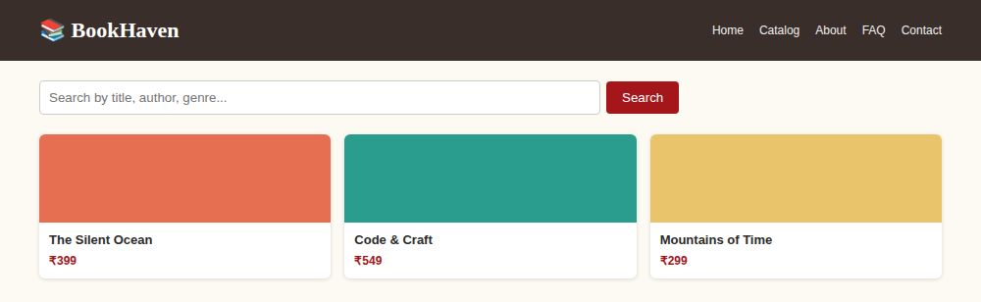

Experiment 38: MyProfessionalShowcase — Personal Portfolio
Design a personal portfolio website with a homepage introduction, an About Me section, a portfolio gallery of projects with links to demos, a downloadable resume page, and a contact form.

Code
<!DOCTYPE html>
<html><head><meta charset="utf-8"><title>MyProfessionalShowcase</title>
<style>
body{font-family:Segoe UI,Arial;margin:0;background:#101820;color:#e8e8e8}
.hero{display:flex;align-items:center;gap:20px;padding:30px 40px}
.avatar{width:70px;height:70px;border-radius:50%;background:#3ddc97}
.hero h1{margin:0;font-size:24px}
.hero p{margin:4px 0 0;color:#9aa5b1;font-size:13px}
nav{display:flex;gap:20px;padding:10px 40px;background:#1b2530;font-size:12px}
nav a{color:#cfd8e3;text-decoration:none}
.grid{display:flex;gap:14px;padding:20px 40px}
.card{flex:1;background:#1b2530;border-radius:8px;padding:14px}
.card h4{margin:0 0 6px;font-size:13px;color:#3ddc97}
.card p{margin:0;font-size:11px;color:#9aa5b1}
</style></head>
<body>
<div class="hero"><div class="avatar"></div><div><h1>Sai Krishnan</h1><p>Full-Stack Developer · React · Node.js · Android</p></div></div>
<nav><a href="#">About</a><a href="#">Portfolio</a><a href="#">Resume</a><a href="#">Blog</a><a href="#">Contact</a></nav>
<div class="grid">
<div class="card"><h4>Smart Resume Verifier</h4><p>Full-stack platform + native Android app</p></div>
<div class="card"><h4>E-Commerce Dashboard</h4><p>React, Node.js, MongoDB</p></div>
<div class="card"><h4>Portfolio API</h4><p>REST API with JWT auth</p></div>
</div>
</body></html>

Output
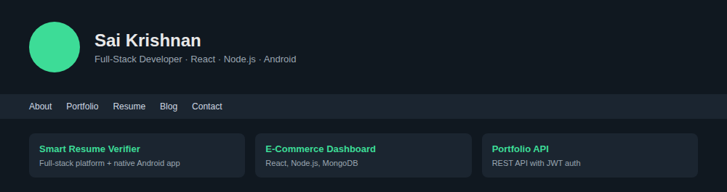

Experiment 39: Gourmet Haven — Fine Dining Restaurant
Design a fine-dining restaurant website with a striking homepage banner, an interactive menu with descriptions and pricing, an online table-reservation system, and an About Us page detailing the restaurant's history.

Code
<!DOCTYPE html>
<html><head><meta charset="utf-8"><title>Gourmet Haven</title>
<style>
body{font-family:Georgia,serif;margin:0;background:#1c1611;color:#f3e9dc}
.hero{height:150px;background:linear-gradient(135deg,#3b2a1a,#7a4b1e);display:flex;align-items:center;justify-content:center;text-align:center}
.hero h1{margin:0;font-size:30px;letter-spacing:1px}
.hero p{font-family:Segoe UI,sans-serif;font-size:12px;color:#e8c99b;letter-spacing:3px;margin-top:6px}
.menu{display:flex;gap:14px;padding:22px 40px;font-family:Segoe UI,sans-serif}
.m{flex:1;background:#2a2119;border-radius:8px;padding:14px}
.m h4{margin:0 0 4px;font-size:14px;color:#e8c99b}
.m p{margin:0;font-size:11px;color:#c9bda9}
.m span{color:#e8c99b;font-weight:bold;font-size:13px;display:block;margin-top:6px}
.res{margin:0 40px 30px;background:#2a2119;border-radius:8px;padding:14px 18px;font-family:Segoe UI,sans-serif;display:flex;gap:10px}
.res input{flex:1;padding:8px;border-radius:4px;border:1px solid #4a3a2a;background:#1c1611;color:#eee}
.res button{background:#e8c99b;color:#1c1611;border:0;padding:8px 18px;border-radius:4px;font-weight:bold}
</style></head>
<body>
<div class="hero"><div><h1>Gourmet Haven</h1><p>F I N E &nbsp; D I N I N G &nbsp; E X P E R I E N C E</p></div></div>
<div class="menu">
<div class="m"><h4>Truffle Risotto</h4><p>Wild mushroom, parmesan</p><span>₹650</span></div>
<div class="m"><h4>Grilled Salmon</h4><p>Lemon butter, herbs</p><span>₹890</span></div>
<div class="m"><h4>Chocolate Fondant</h4><p>Vanilla bean ice cream</p><span>₹340</span></div>
</div>
<div class="res"><input placeholder="Date"><input placeholder="Time"><input placeholder="Guests"><button>Reserve Table</button></div>
</body></html>

Output
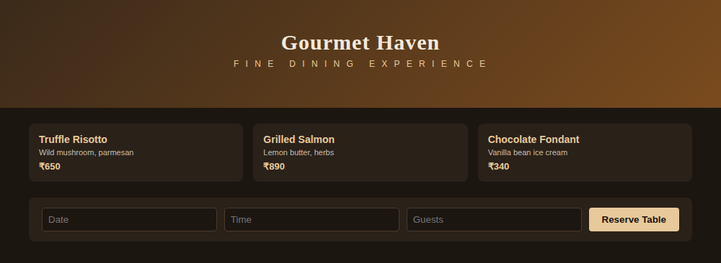

Experiment 40: SimpleShop — Online Store Product Catalog
Design an online store homepage with featured products and category navigation, individual product listings with images/price/options, a shopping cart to add and adjust items, and a secure checkout process.

Code
<!DOCTYPE html>
<html><head><meta charset="utf-8"><title>SimpleShop</title>
<style>
body{font-family:Segoe UI,Arial;margin:0;background:#fff;color:#222}
header{background:#111;color:#fff;padding:16px 40px;display:flex;justify-content:space-between;align-items:center}
header h1{margin:0;font-size:20px}
.cart{background:#ff5a5f;padding:6px 12px;border-radius:4px;font-size:12px}
.filters{display:flex;gap:10px;padding:14px 40px;background:#f7f7f7}
.filters select{padding:6px;border:1px solid #ddd;border-radius:4px;font-size:12px}
.grid{display:flex;gap:14px;padding:20px 40px}
.p{flex:1;border:1px solid #eee;border-radius:8px;overflow:hidden}
.p .img{height:90px}
.i1{background:#ffd6a5}.i2{background:#a0c4ff}.i3{background:#bdb2ff}.i4{background:#caffbf}
.p .body{padding:10px}
.p h4{margin:0 0 4px;font-size:13px}
.p span{color:#111;font-weight:bold;font-size:13px}
.p button{width:100%;margin-top:8px;padding:7px;background:#111;color:#fff;border:0;border-radius:4px;font-size:12px}
</style></head>
<body>
<header><h1>🛒 SimpleShop</h1><span class="cart">Cart (2)</span></header>
<div class="filters"><select><option>Category</option><option>Electronics</option><option>Clothing</option></select><select><option>Price</option></select><select><option>Popularity</option></select></div>
<div class="grid">
<div class="p"><div class="img i1"></div><div class="body"><h4>Wireless Earbuds</h4><span>₹1,499</span><button>Add to Cart</button></div></div>
<div class="p"><div class="img i2"></div><div class="body"><h4>Cotton T-Shirt</h4><span>₹499</span><button>Add to Cart</button></div></div>
<div class="p"><div class="img i3"></div><div class="body"><h4>Backpack</h4><span>₹1,199</span><button>Add to Cart</button></div></div>
<div class="p"><div class="img i4"></div><div class="body"><h4>Table Lamp</h4><span>₹799</span><button>Add to Cart</button></div></div>
</div>
</body></html>

Output
